**Web Application Security Assessment and SQL Injection Testing project:**

1. **Select a Vulnerable Web Application:**

Choose a vulnerable web application designed for testing SQL injection vulnerabilities, such as Damn Vulnerable Web Application

(DVWA)

1. **SQL Injection Testing:**

Start with basic SQL injection techniques such as inserting SQL code into input fields to manipulate database queries.

**Access DVWA:**

Open your web browser and navigate to the Damn Vulnerable Web Application (DVWA) login page.

**Login to DVWA:**

Use the default credentials (username: admin, password: password) to log in to DVWA.

**Set Security Level:**

Navigate to the DVWA security settings and set the security level to "Low" or "Medium" to make SQL injection vulnerabilities easier to exploit. This setting can be found under the "DVWA Security" tab.

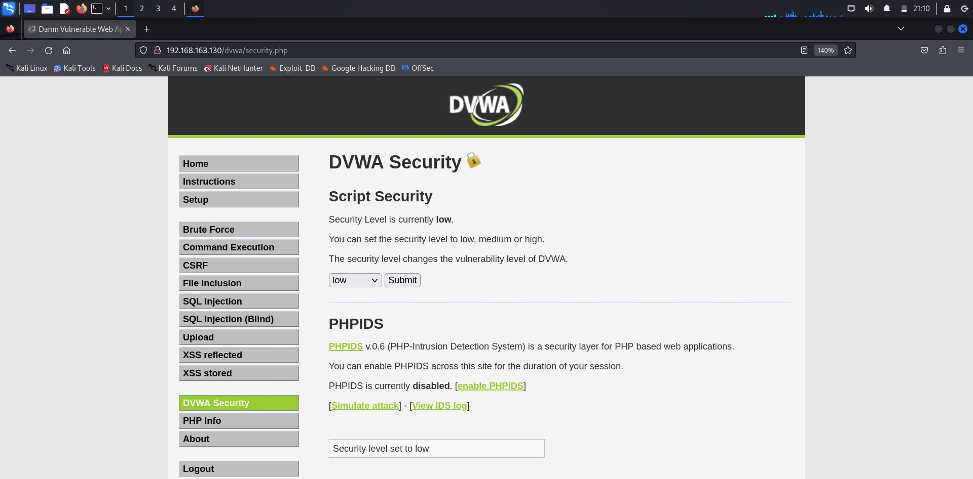

**Navigate to SQL Injection:**

Once logged in, navigate to the "SQL Injection" section within DVWA, typically located under the "DVWA Security" tab.

**Select Vulnerable Page:**

Choose a vulnerable page within DVWA to test for SQL injection. Common options include the "SQL Injection - String" or "SQL Injection - Integer" pages.

**Inspect Page Source Code:**

Right-click on the input field where user input is accepted (e.g., text box) and select "Inspect" or "View Page Source" to view the underlying HTML code.

**Identify Input Field:**

Identify the input field name or parameter in the HTML code. This is where you'll inject SQL queries.

**Perform Basic SQL Injection:**

In the input field, enter a basic SQL injection payload such as:

' OR 1=1 --

Submit the form and observe the response. If the page behaves differently or returns additional data, it may indicate a successful SQL injection.

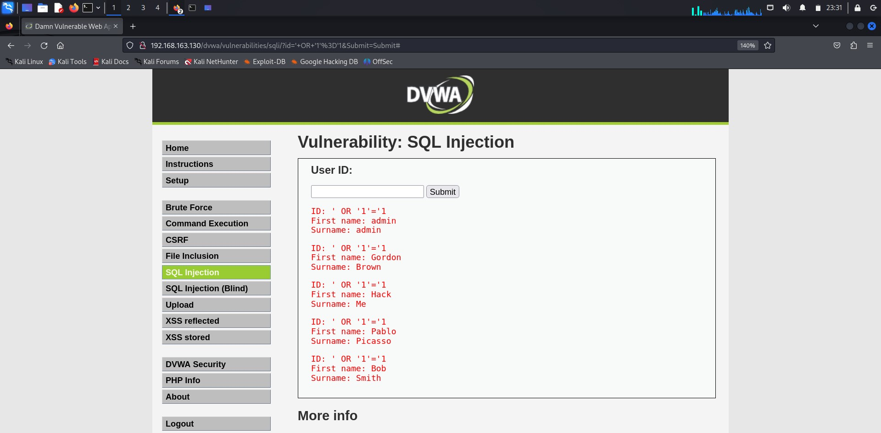

**Test for Error Messages:**

Inject malformed SQL queries to trigger error messages. For example:

'1' OR '1'='1

Look for error messages that disclose database-related information, such as table names or column names.

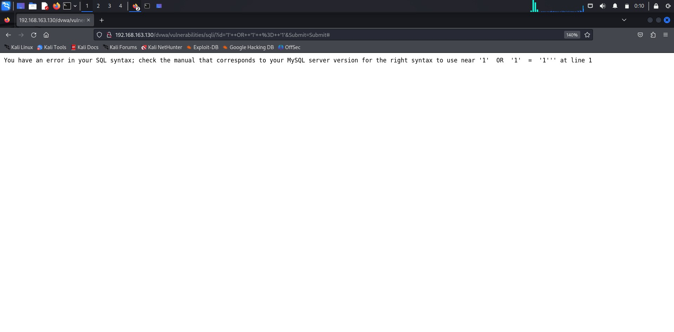

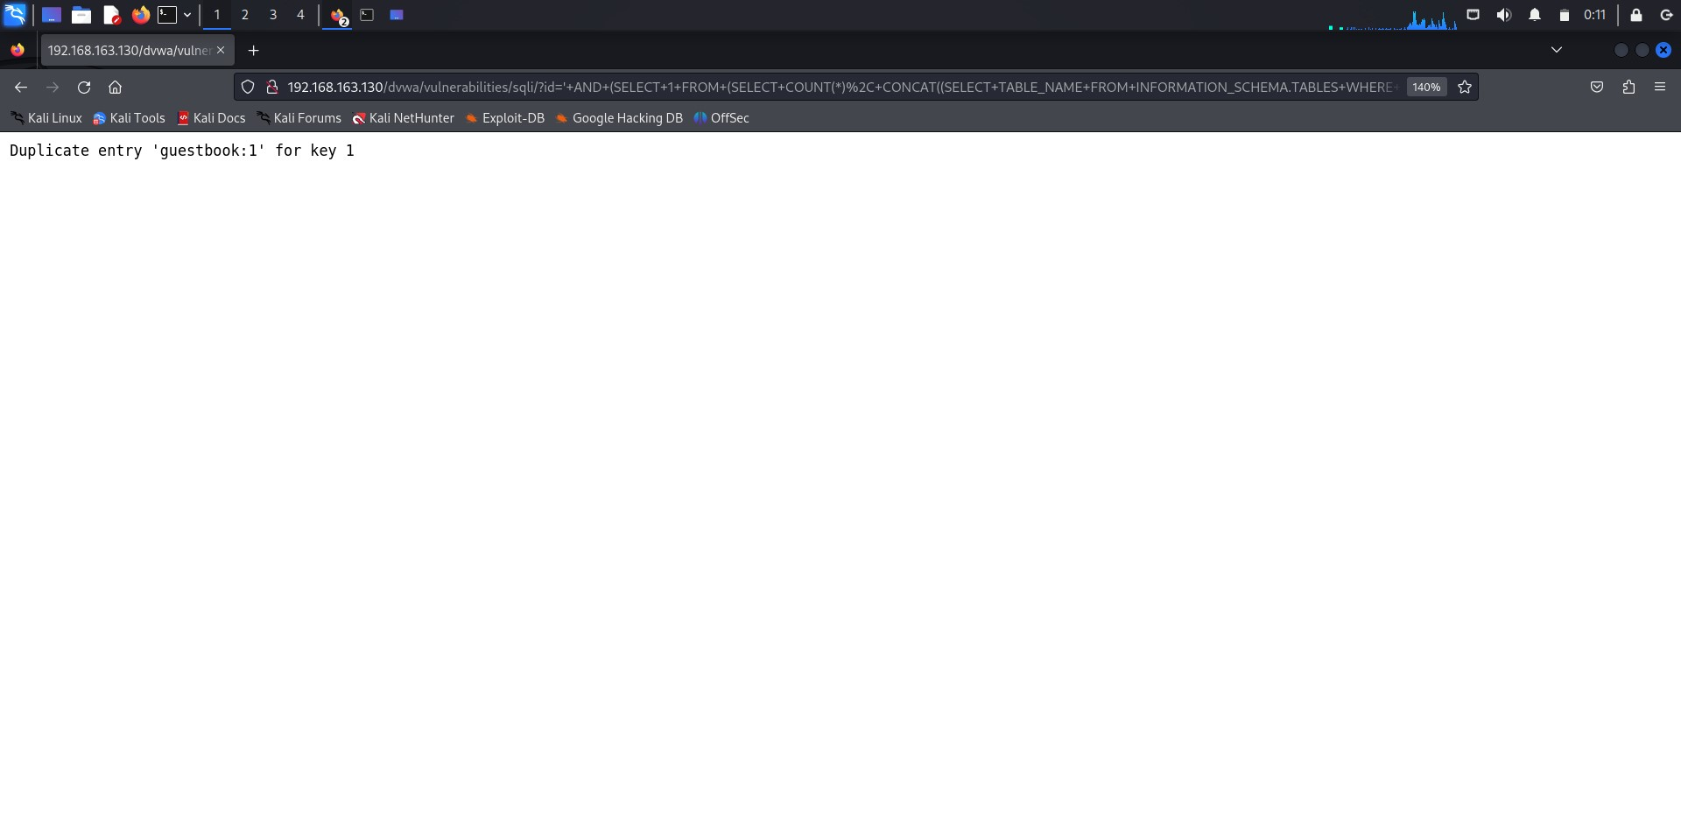

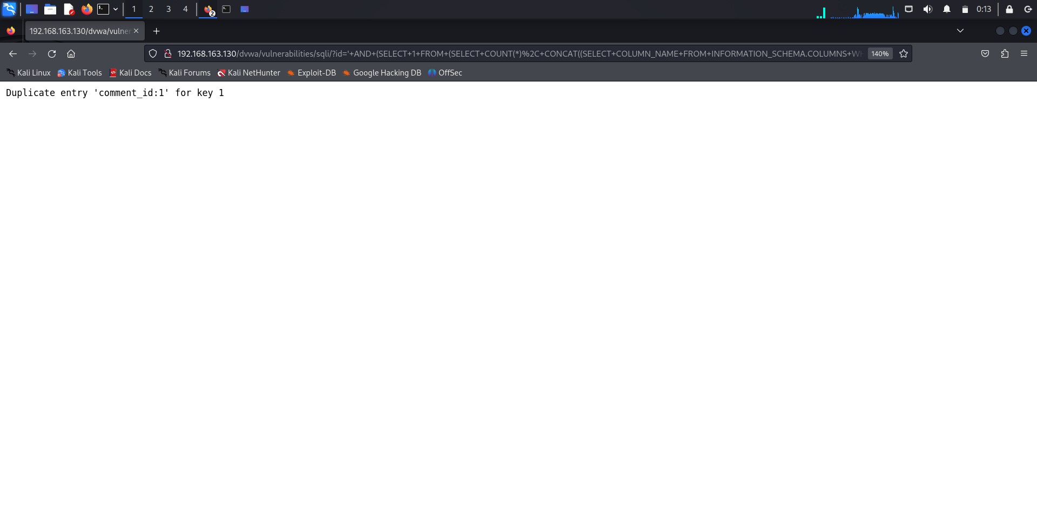

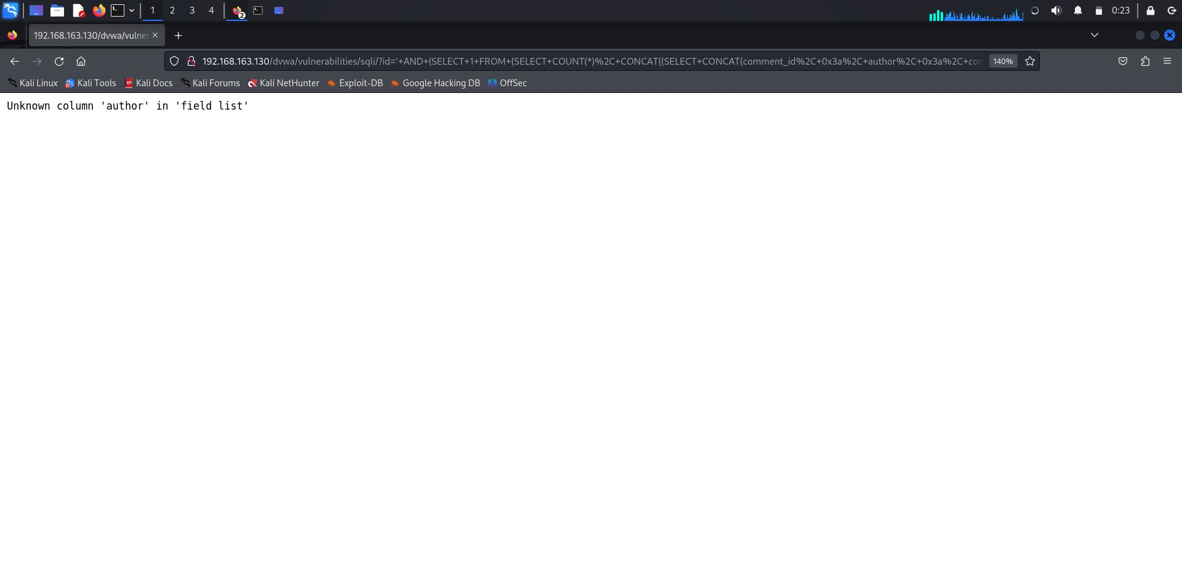

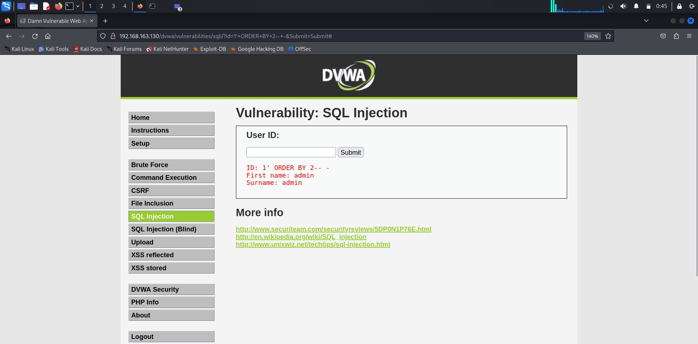

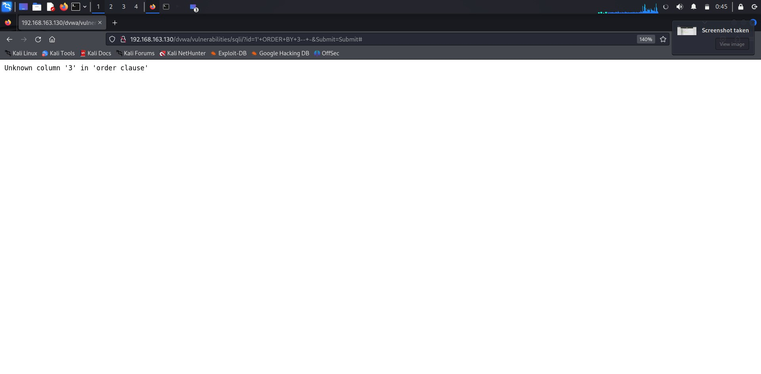

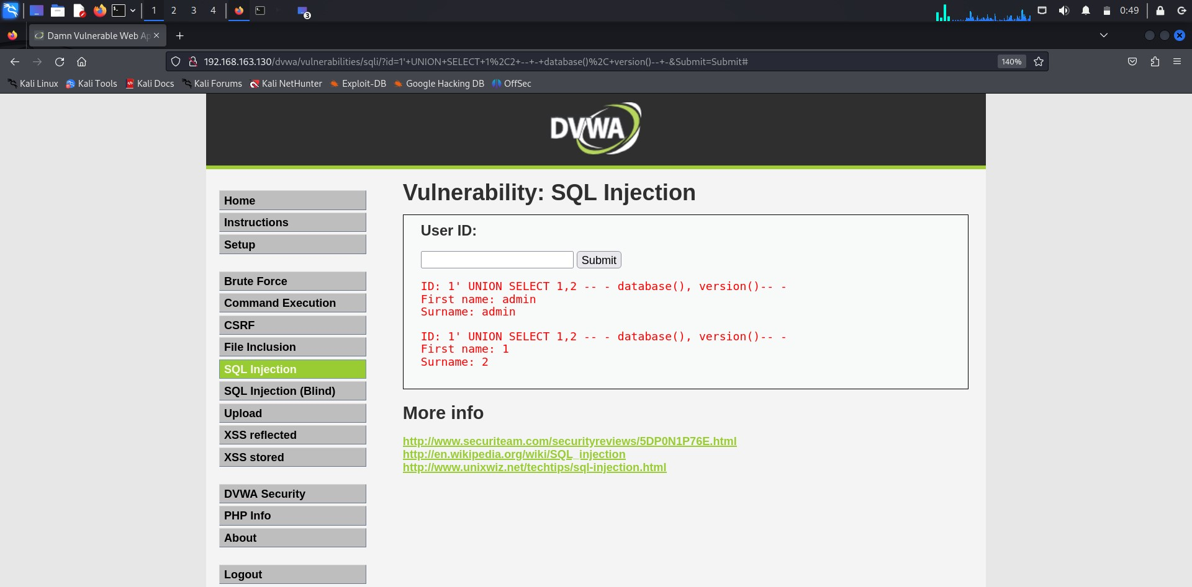

**Explore Advanced Techniques:**

Experiment with more advanced SQL injection techniques such as blind SQL injection and time-based blind injection.

Craft payloads to extract data from the database, bypass authentication, or perform other malicious actions.

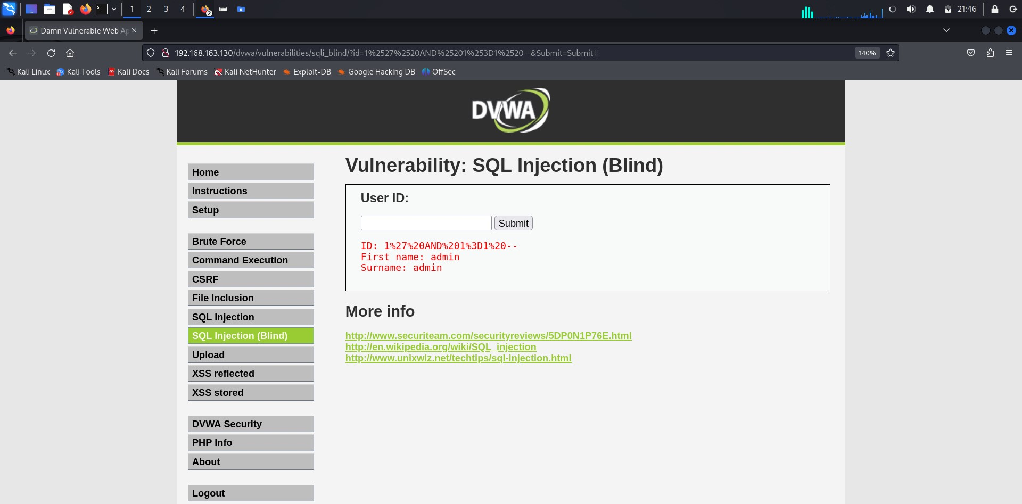

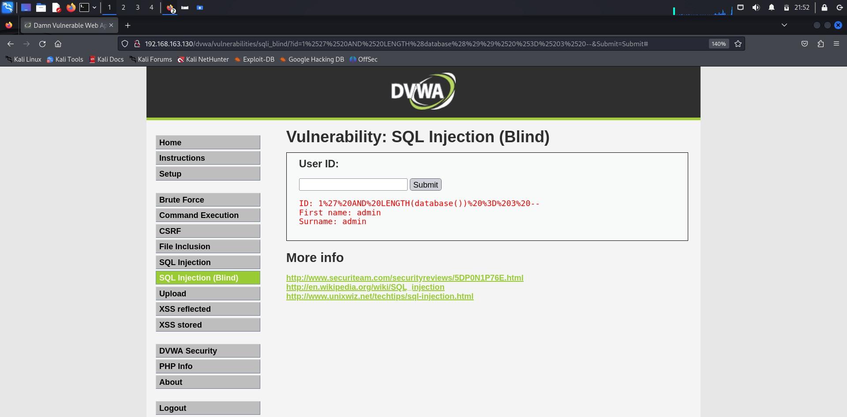

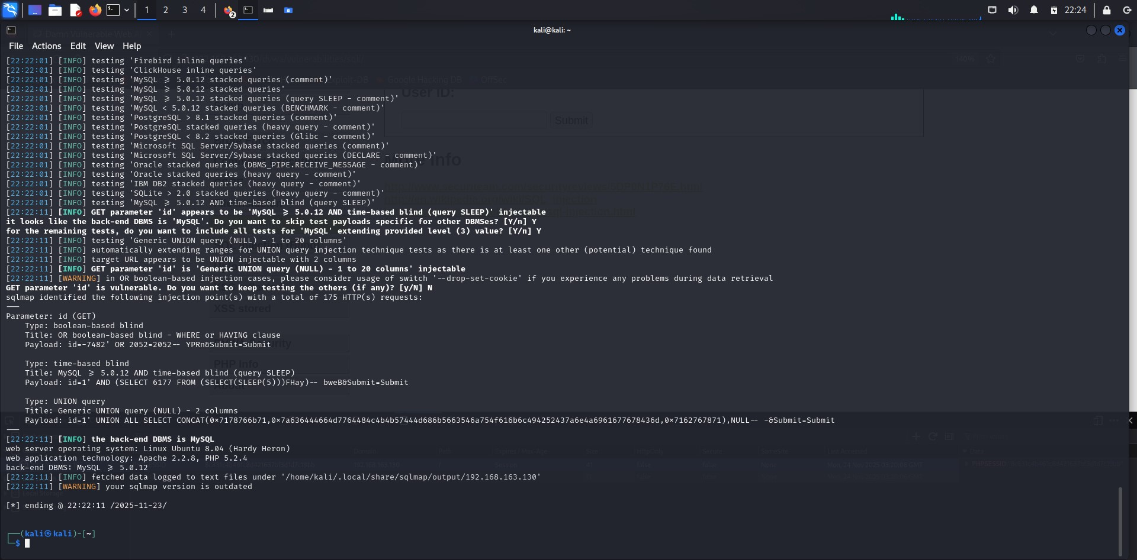

**Document Findings:**

Document the SQL injection payloads used, the responses received, and any data extracted from the database. Note any vulnerabilities discovered, including their severity and potential impact.

**Repeat Testing:**

Repeat the testing process on different input fields or pages within DVWA to thoroughly assess the application's susceptibility to SQL injection.

1. **Hands-On Exploitation:**

Document the steps to exploit SQL injection vulnerabilities discovered during testing, including the SQL payloads used and the data retrieved.

Emphasize the potential risks associated with successful SQL injection attacks, such as data leakage, unauthorized access, and data manipulation.

1. **Automated Testing:**

Utilize automated SQL injection testing tools like SQLMap or Havij to streamline the testing process and identify vulnerabilities efficiently.

Document the usage of automated tools and analyze the results they provide.

Here's a step-by-step guide on how to use SQLMap in Kali Linux to perform automated SQL injection testing on Damn Vulnerable Web

**Application (DVWA):**

a. Launch Kali Linux Terminal:

Open a terminal window in Kali Linux.

Enter the following command to run SQLMap with the target DVWA URL:

sqlmap -u "http://your-dvwa-url.com/login.php"

Replace "http://your-dvwa-url.com/login.php" with the URL of your DVWA login page or the specific page you want to test for SQL injection vulnerabilities.

Specify Testing Parameters (Optional):

If DVWA authentication is enabled, you may need to specify login credentials. Use the -u parameter to specify the target URL and the

-data parameter to provide login credentials. For example: sqlmap -u "http://your-dvwa-url.com/login.php" -data="username=admin&password=password&Login=Login"

Once the command is entered, SQLMap will automatically start scanning the target DVWA instance for SQL injection vulnerabilities.

SQLMap will display real-time feedback on its progress, including the number of requests sent, payloads tested, and vulnerabilities discovered.

After the automated testing process is complete, SQLMap will provide a summary of the vulnerabilities identified, including their severity and potential impact.

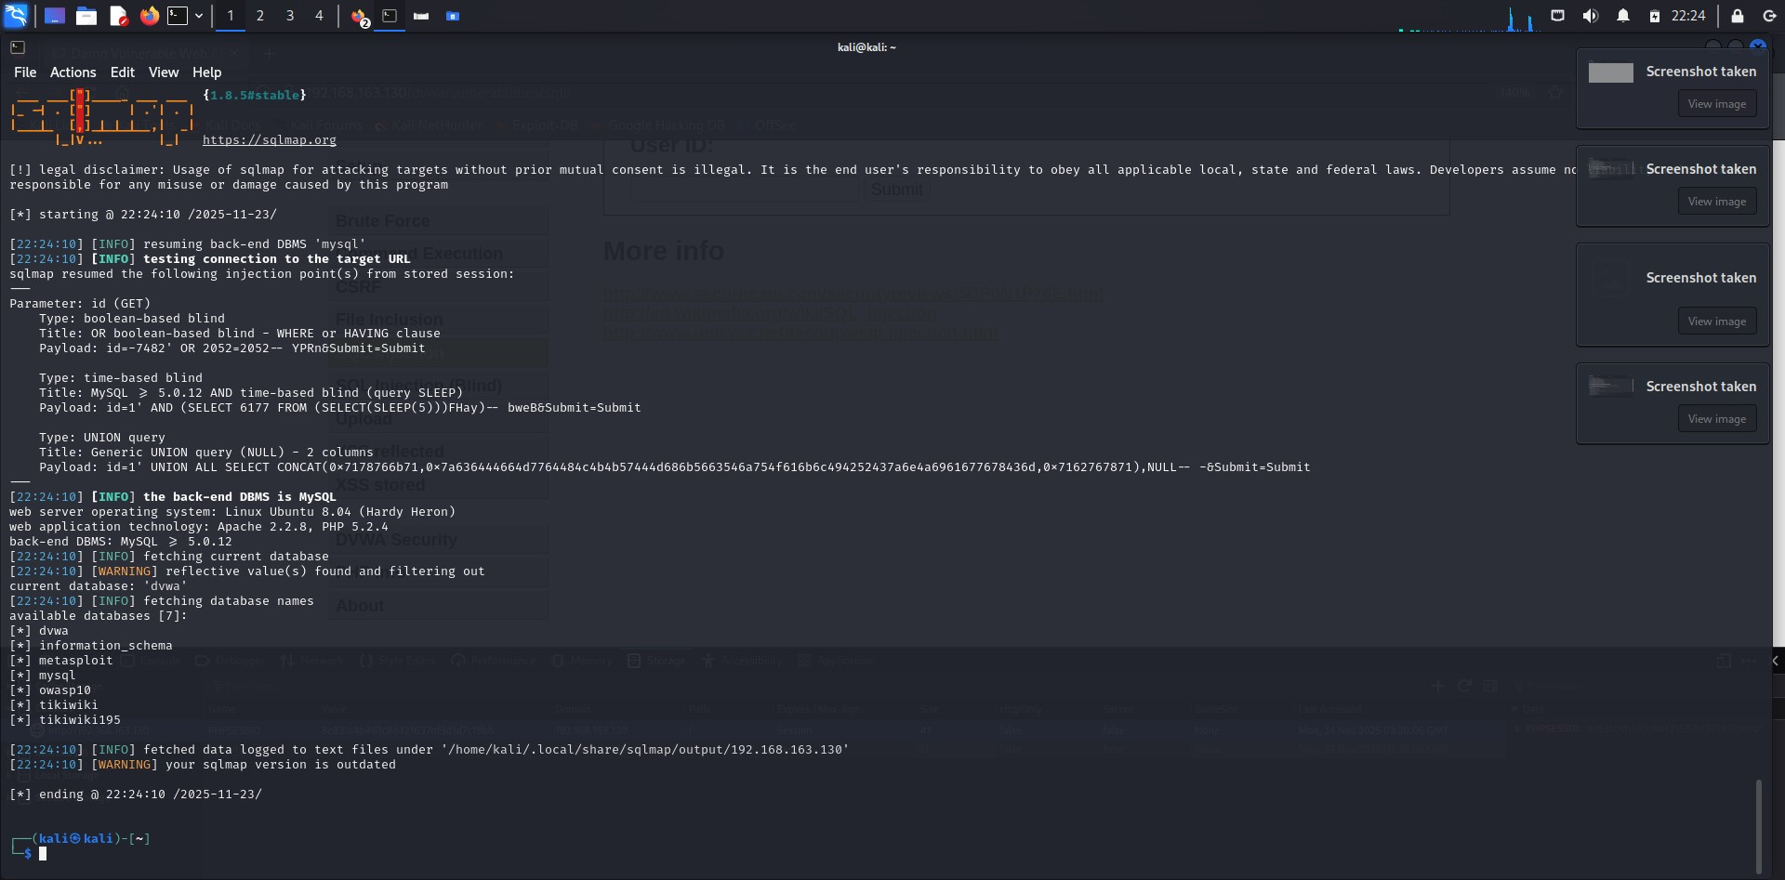

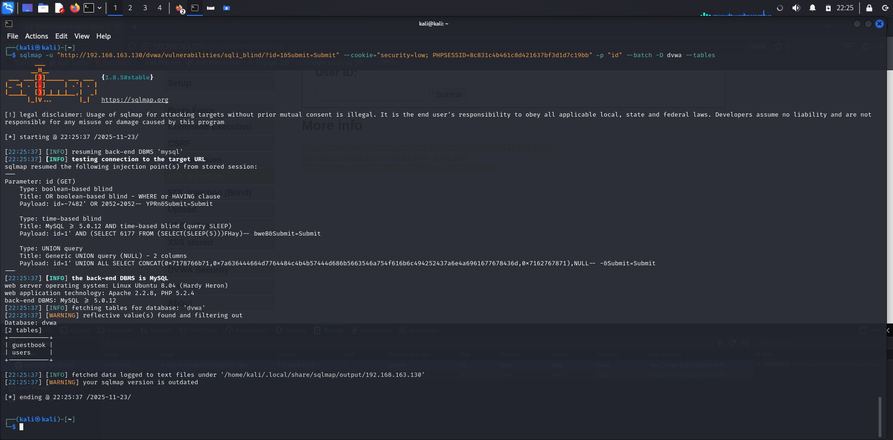

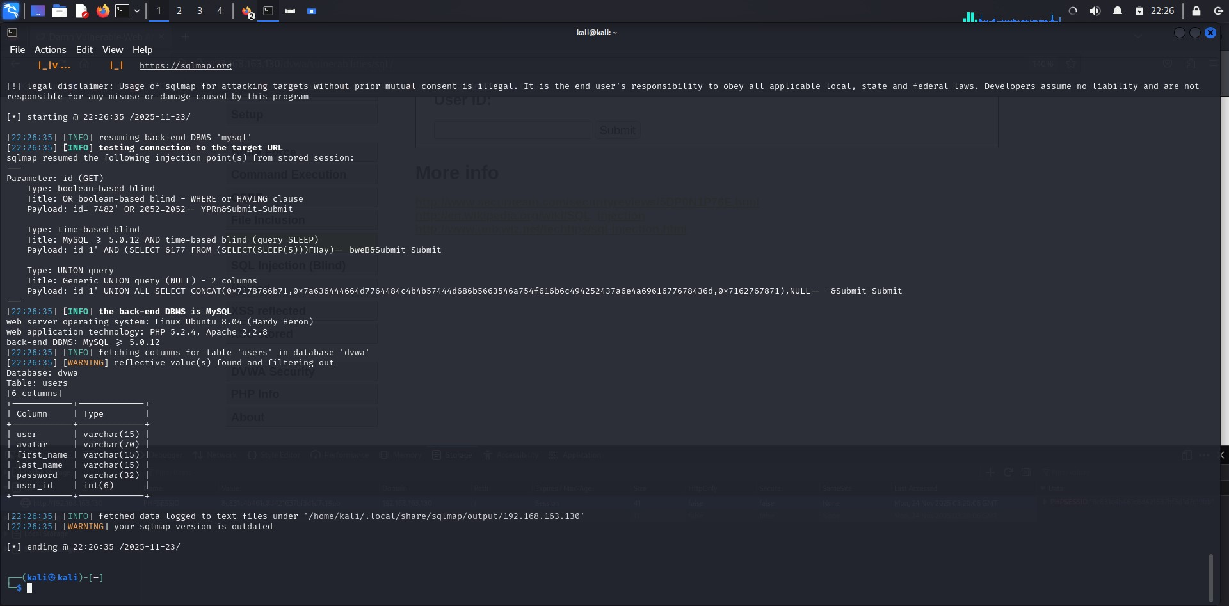

Document the usage of SQLMap, including the commands used and any challenges encountered during the testing process.

Analyze the results provided by SQLMap and document the vulnerabilities identified, their severity, and any additional insights gained from the automated testing.

Cross-verify the vulnerabilities identified by SQLMap with manual testing techniques to ensure accuracy and completeness.

Conduct additional manual testing if necessary to validate SQLMap's findings.

By following these steps and using SQLMap in Kali Linux, you can effectively perform automated SQL injection testing on Damn Vulnerable Web Application (DVWA) to identify vulnerabilities efficiently. Remember to conduct all testing ethically and within a controlled environment.

**6. Authentication Bypass:**

Explore SQL injection techniques for bypassing authentication mechanisms within the web application.

Document successful authentication bypass methods and discuss their implications on the application's security.

Now we will ses how to explore SQL injection techniques for bypassing authentication mechanisms within Damn Vulnerable Web Application (DVWA):

Before attempting to bypass authentication, it's crucial to understand how the authentication mechanism works in DVWA. Familiarize yourself with the login process and the parameters involved.

Determine the parameters involved in the authentication process, such as username and password fields.

Start by logging in to DVWA using legitimate credentials to observe the normal authentication process.

Use browser developer tools or intercepting proxies like Burp Suite to capture the login request sent to the server. Analyze the structure of the request, including the parameters passed to the server.

Attempt to inject SQL payloads into the authentication parameters to manipulate the login process.

Focus on injecting payloads that may bypass authentication checks or alter the SQL queries executed by the server.

Here's how we will do this:

* Launch Browser Developer Tools:
* Open your web browser (e.g., Firefox or Chrome).
* Navigate to the login page of DVWA.
* Right-click on the login page and select "Inspect" or "Inspect Element" to open the browser developer tools.
* Now Capture the Login Request:
* In the developer tools, go to the "Network" tab.
* Enter valid credentials (e.g., username: admin, password: password) and click the "Login" button.
* Capture the login request sent to the server by DVWA.
* In the captured request, identify the parameters involved in the authentication process, such as username and password.

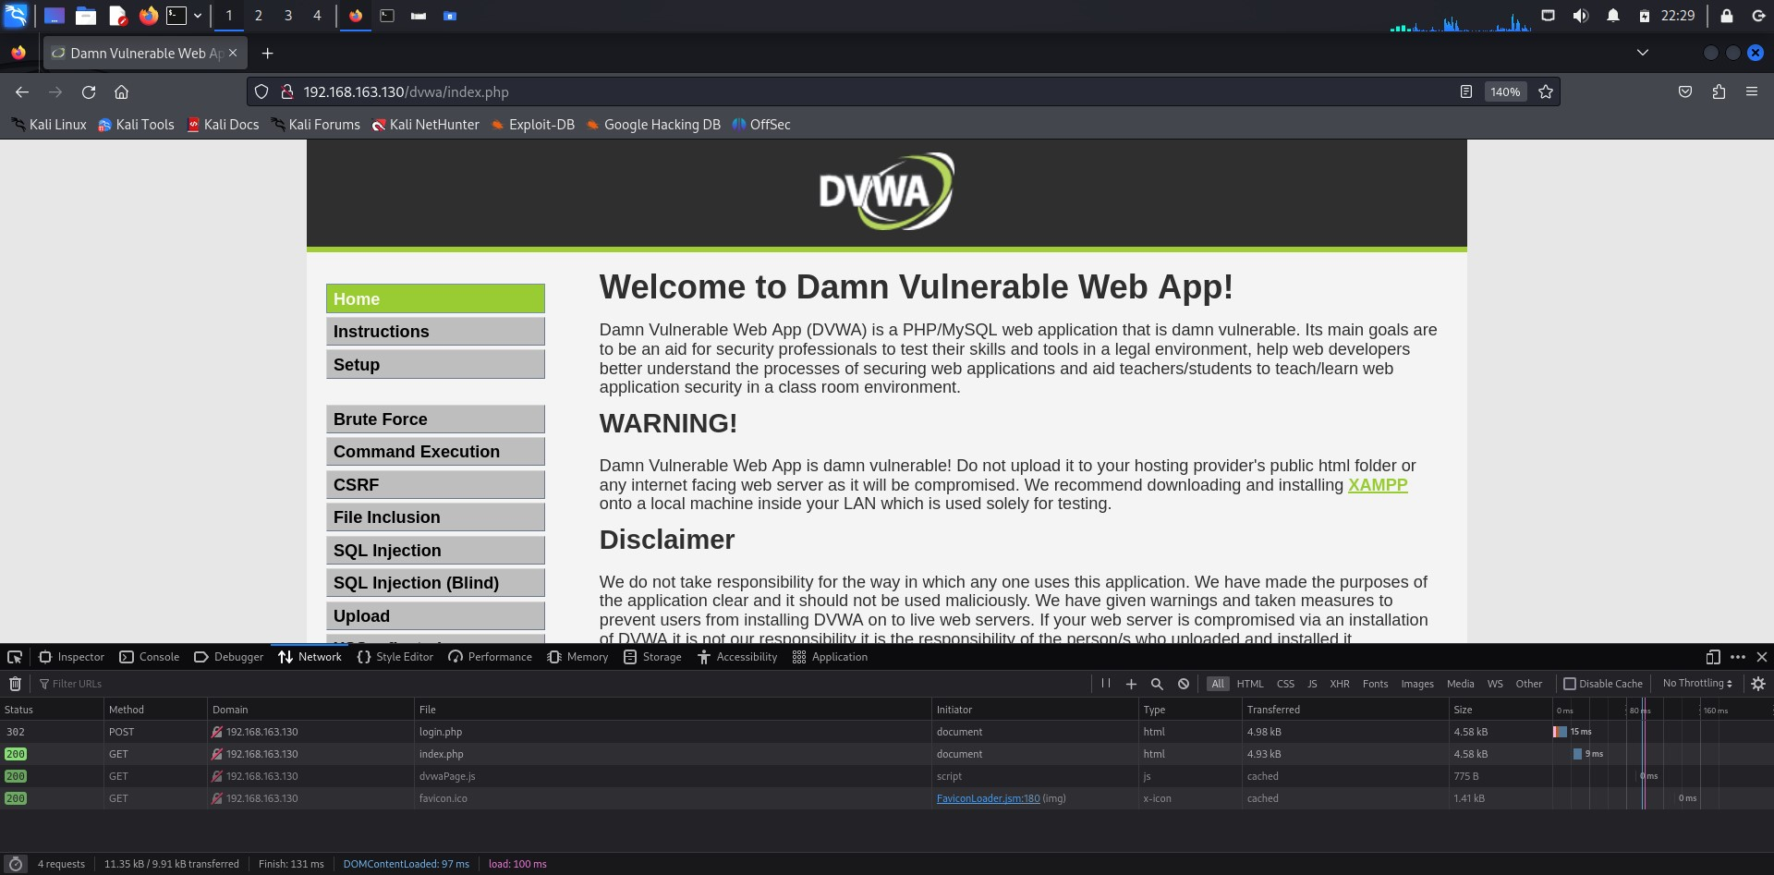

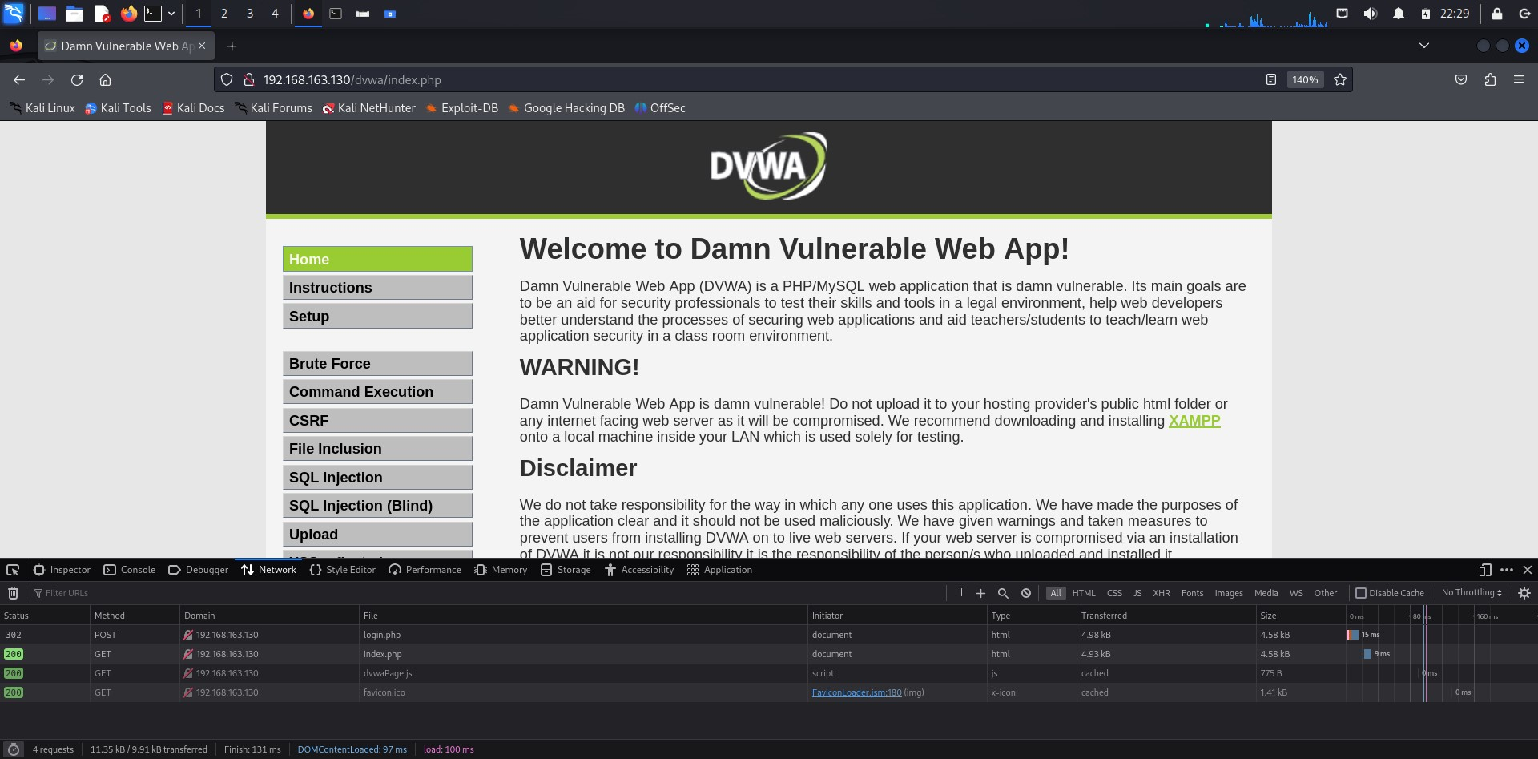

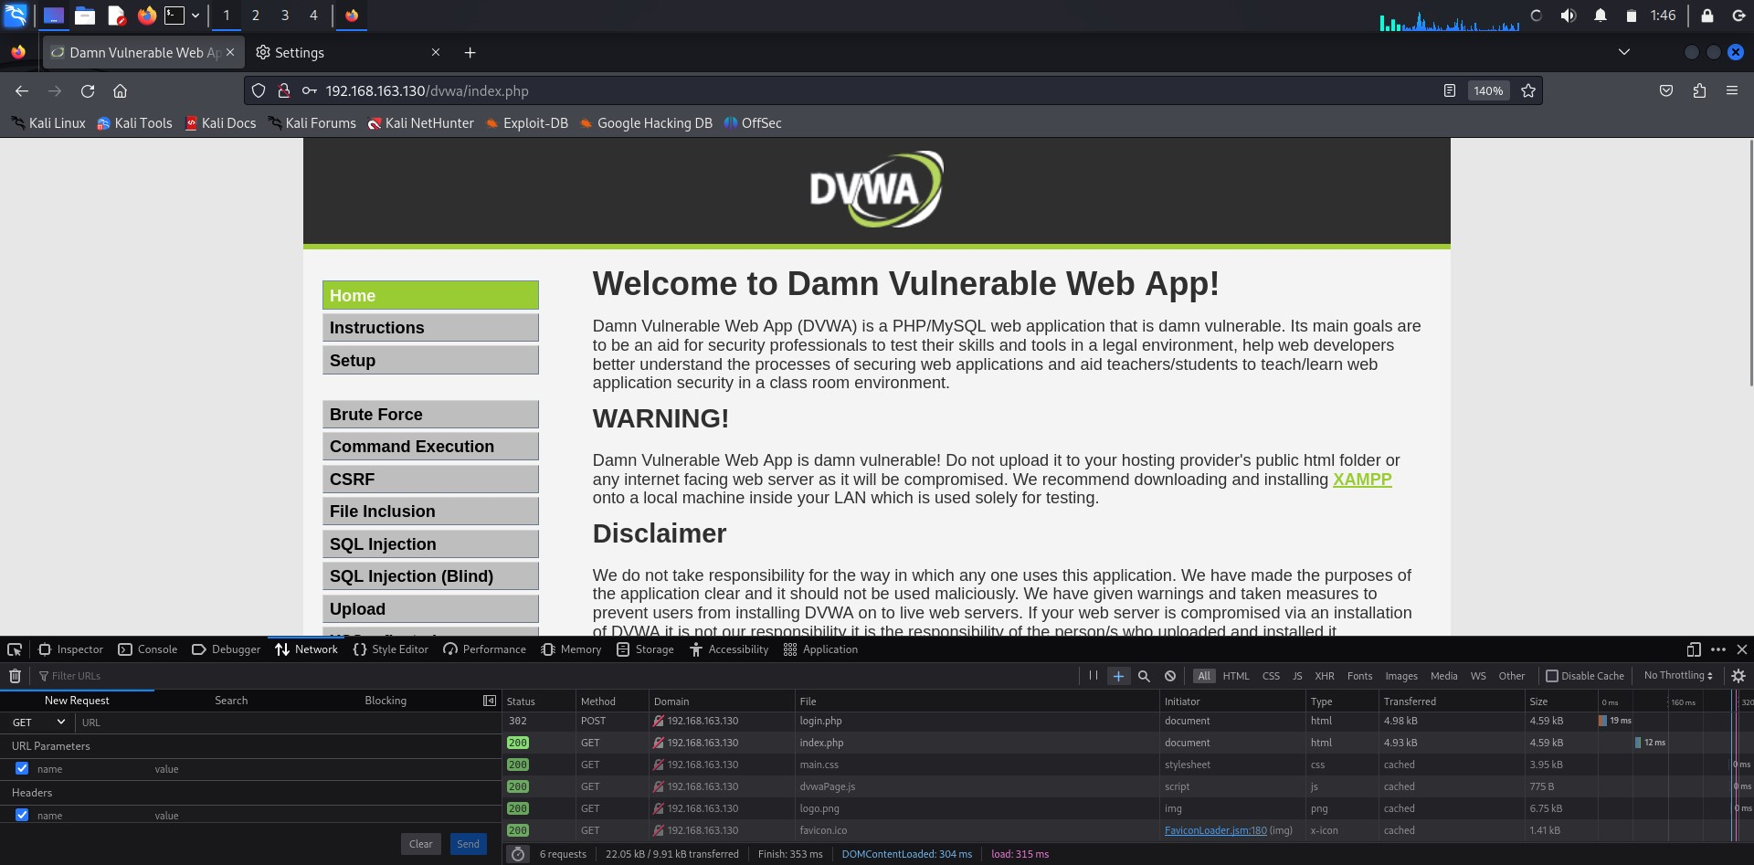

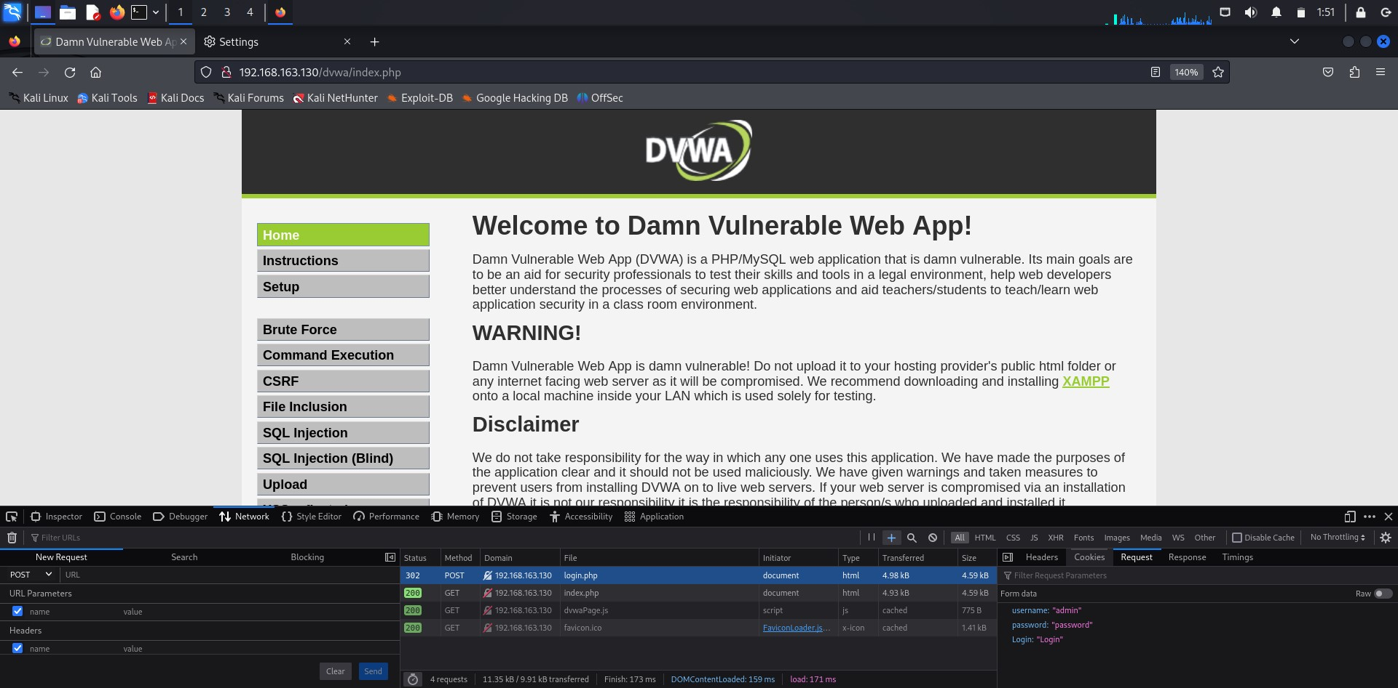

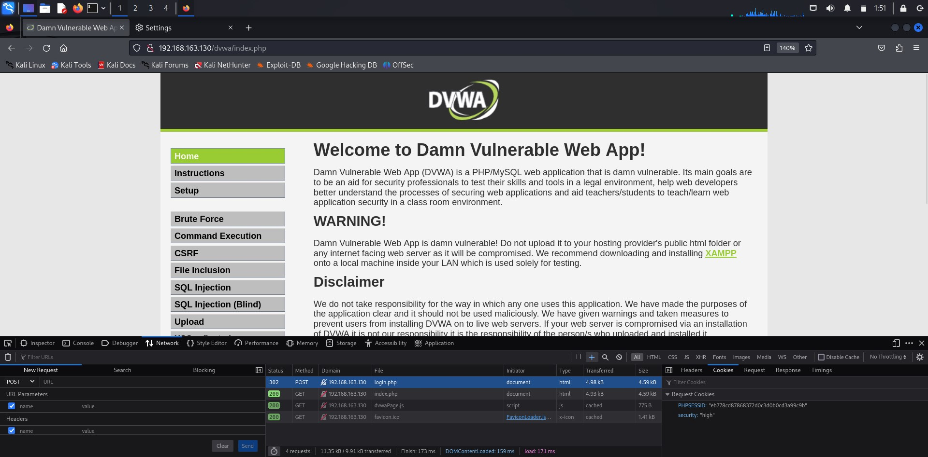

And go ahead and Inject SQL Payloads now :

Modify the value of the username or password parameter to inject SQL payloads.

For example, **try injecting a simple SQL payload like ' OR 1=1 --** into the username parameter.

**Observe Server Responses:**

Observe the responses received from the server after injecting SQL payloads.

Look for any changes in behavior, such as error messages, redirections, or successful login without valid credentials.

**Test Different Injection Techniques:**

Experiment with various SQL injection techniques, including UNION-based, error-based, and time-based injections.

Modify the injected payloads based on the observed responses to refine the bypass technique.

**Document Successful Bypass Methods:**

Document any successful authentication bypass methods, including the SQL payloads used and the observed outcomes.

Describe how each bypass method exploits vulnerabilities in the authentication mechanism.

Discuss the implications of successful authentication bypass on the security of the DVWA application.

Highlight the risks associated with bypassing authentication, such as unauthorized access to sensitive data or administrative functionalities.

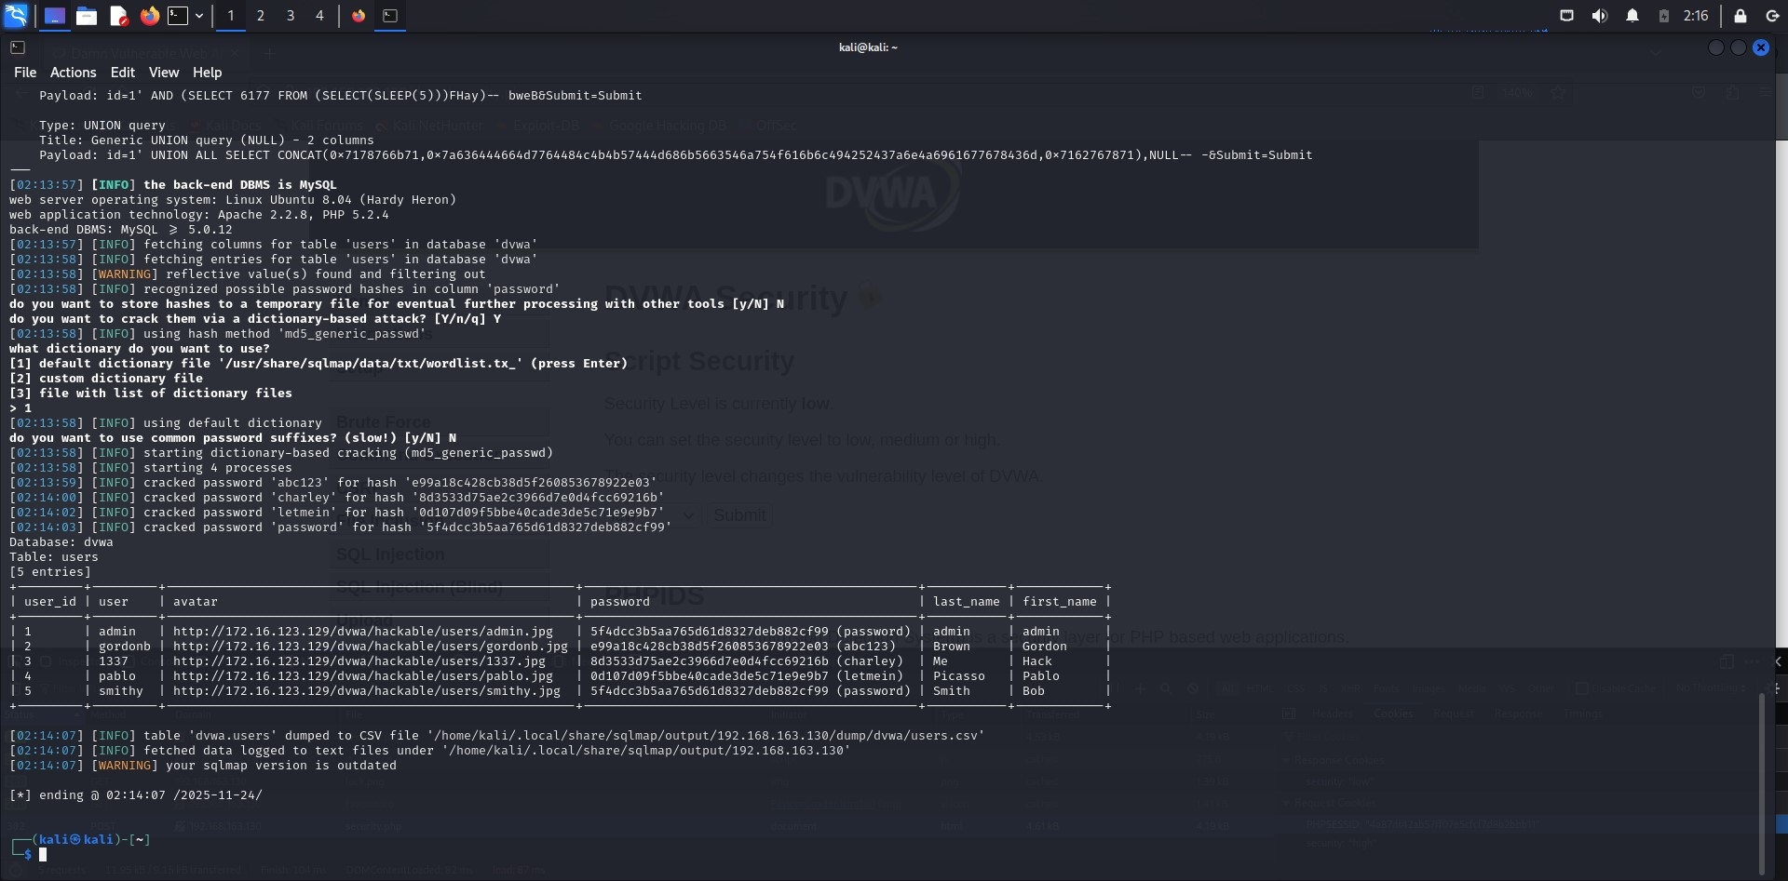

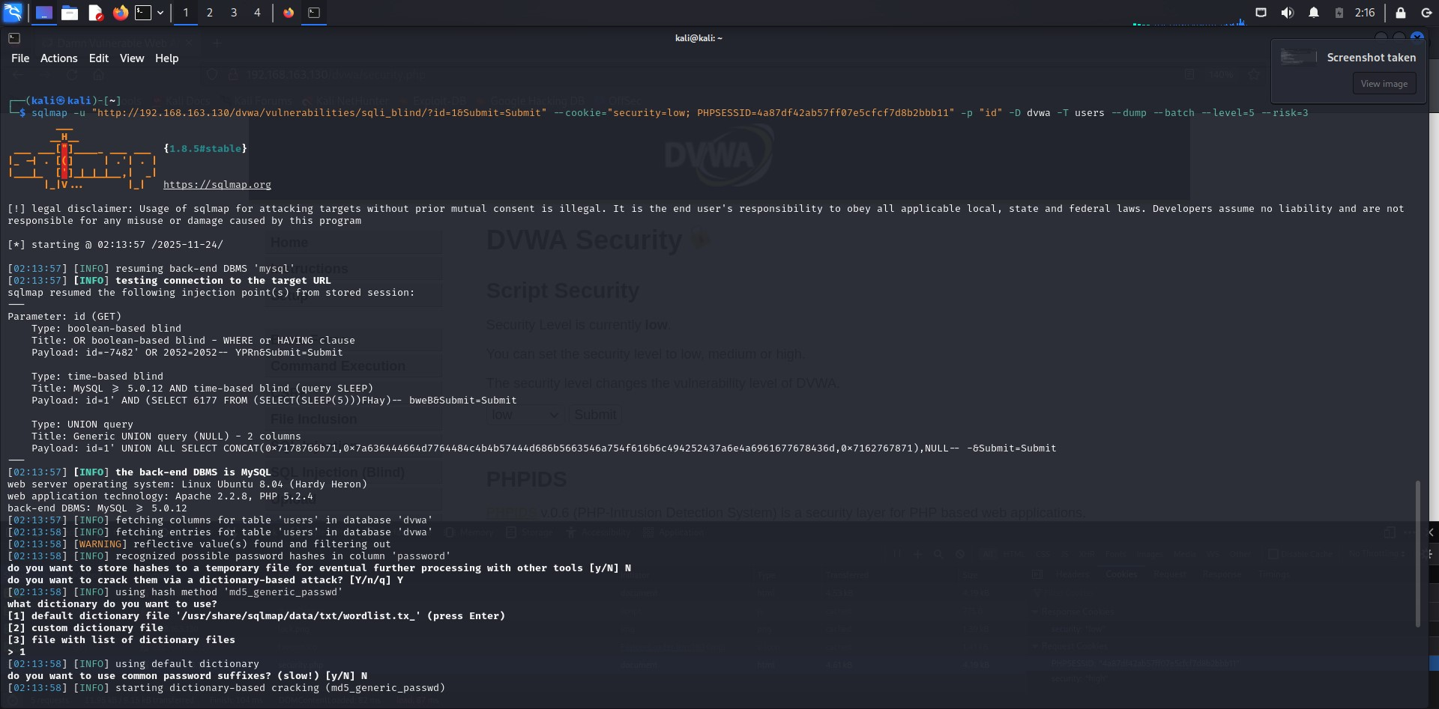

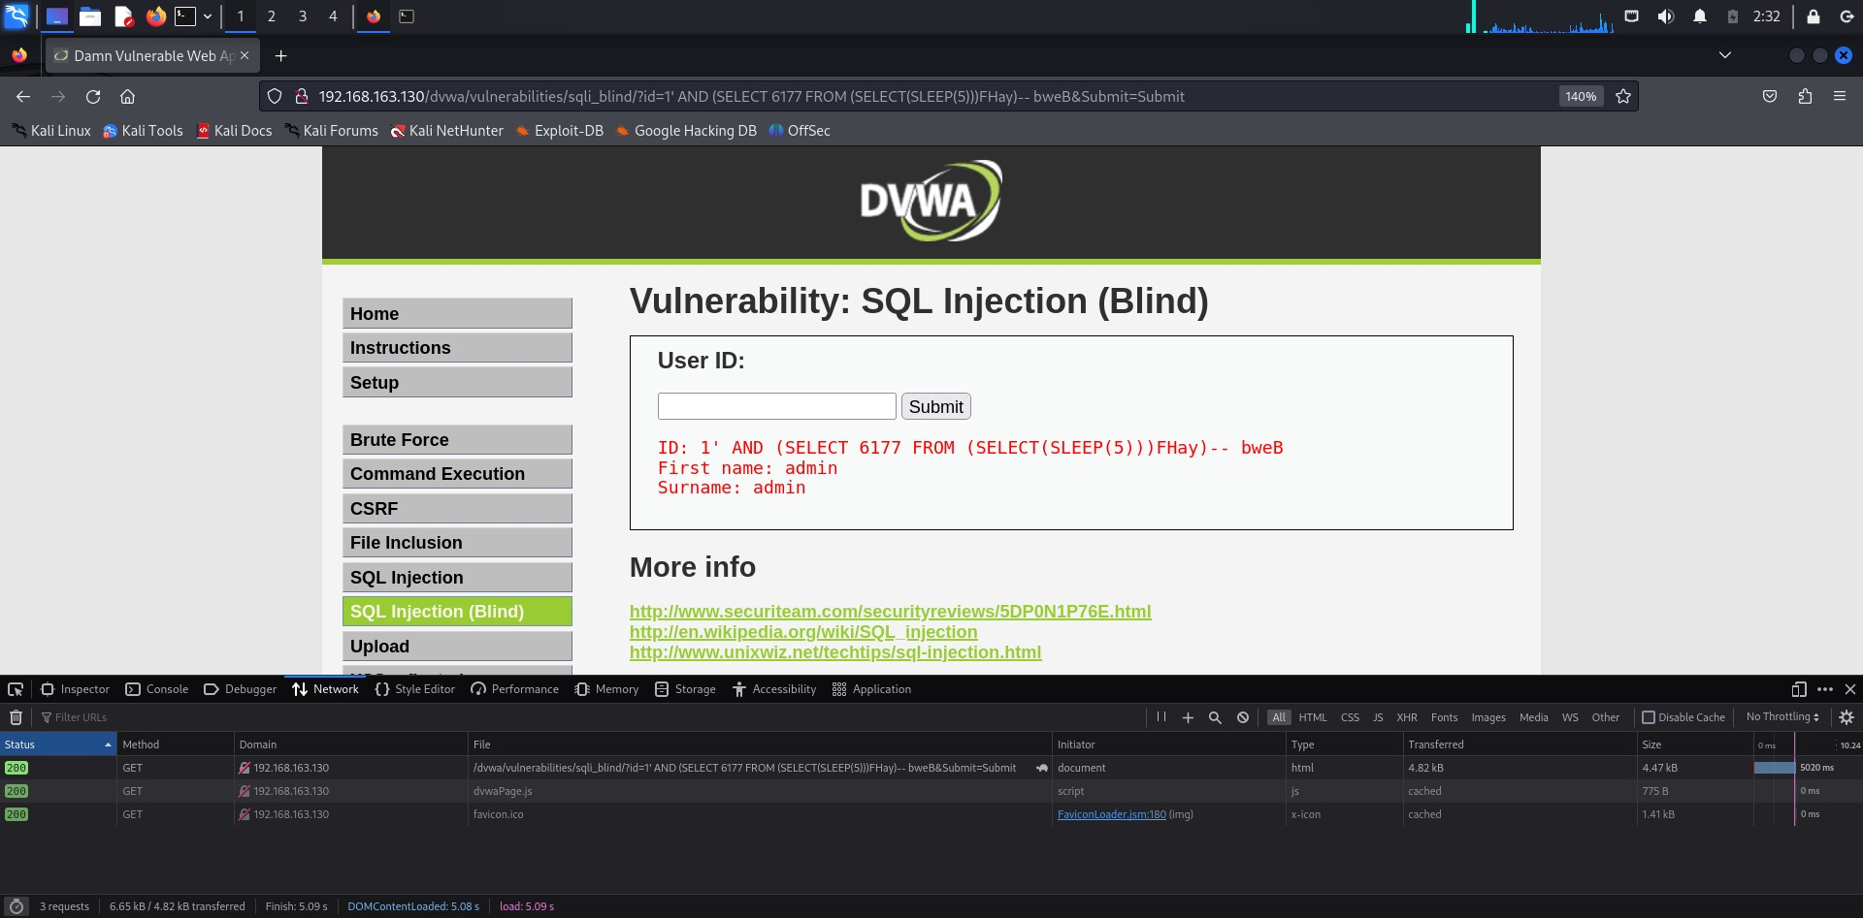

**Propose Mitigation Strategies:**

* Propose mitigation strategies to address the vulnerabilities exploited during the authentication bypass.
* Recommend measures such as input validation, parameterized queries, and strong password policies to improve security.

**Document Findings**:

* Document the entire process of exploring authentication bypass techniques, including the steps taken, payloads used, and outcomes observed.
* Organize the documentation for future reference and knowledge sharing.

**7. Parameter Tampering:**

Investigate SQL injection for parameter tampering with both GET and POST requests to manipulate application behavior.

Parameter tampering involves manipulating the parameters of a request sent to a web application to alter its behavior. In the context of SQL injection, parameter tampering can be used to modify SQL queries executed by the application. **a. Identify Target Parameters:**

Identify the parameters within both GET and POST requests that interact with the application's backend database. These parameters may include inputs such as search queries, user IDs, or form fields related to database operations. **b. Explore GET Request Tampering:**

Use browser developer tools or intercepting proxies like Burp Suite to capture and modify GET requests sent to the DVWA application.

Identify parameters in the URL query string that can be manipulated for SQL injection.

Modify these parameters to inject SQL payloads and observe the application's response.

Suppose we have a web application, such as Damn Vulnerable Web Application (DVWA), where users can search for products by entering keywords in the search bar. The search functionality generates a GET request to the server with the search query as a parameter in the URL.

* Open your web browser and navigate to the DVWA application.
* Go to the search page or any page with a search functionality where users can enter keywords.
* Right-click on the search input field and select "Inspect" or "Inspect Element" to open the browser developer tools.
* Switch to the "Network" tab within the developer tools.
* Enter a search term (e.g., "apple") in the search bar and press Enter to submit the search query.
* In the developer tools' Network tab, you should see a new entry corresponding to the search request.
* Click on the entry to view detailed information about the GET request.
* Note the URL of the request, which should include the search query parameter (e.g., ?q=apple).
* Right-click on the captured GET request and select "Copy" > "Copy as cURL" to copy the request as a cURL command.
* Paste the copied cURL command into a text editor.
* Modify the search query parameter value in the URL (e.g., change ?q=apple to ?q=apple' OR '1'='1).
* Open a terminal window and paste the modified cURL command to send the modified GET request to the server.
* Check the response from the server to see if it differs from the original response.
* Look for any changes in the application's behavior, such as displaying additional search results or error messages.
* Analyze the impact of the modified search query parameter on the application's behavior.
* If the application responds differently or displays unexpected behavior, it may indicate a successful SQL injection vulnerability

through GET request tampering.

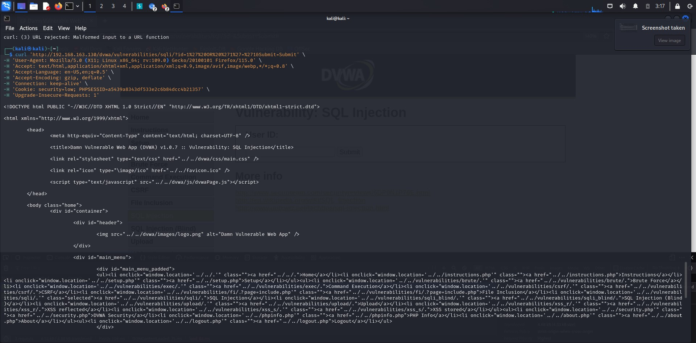

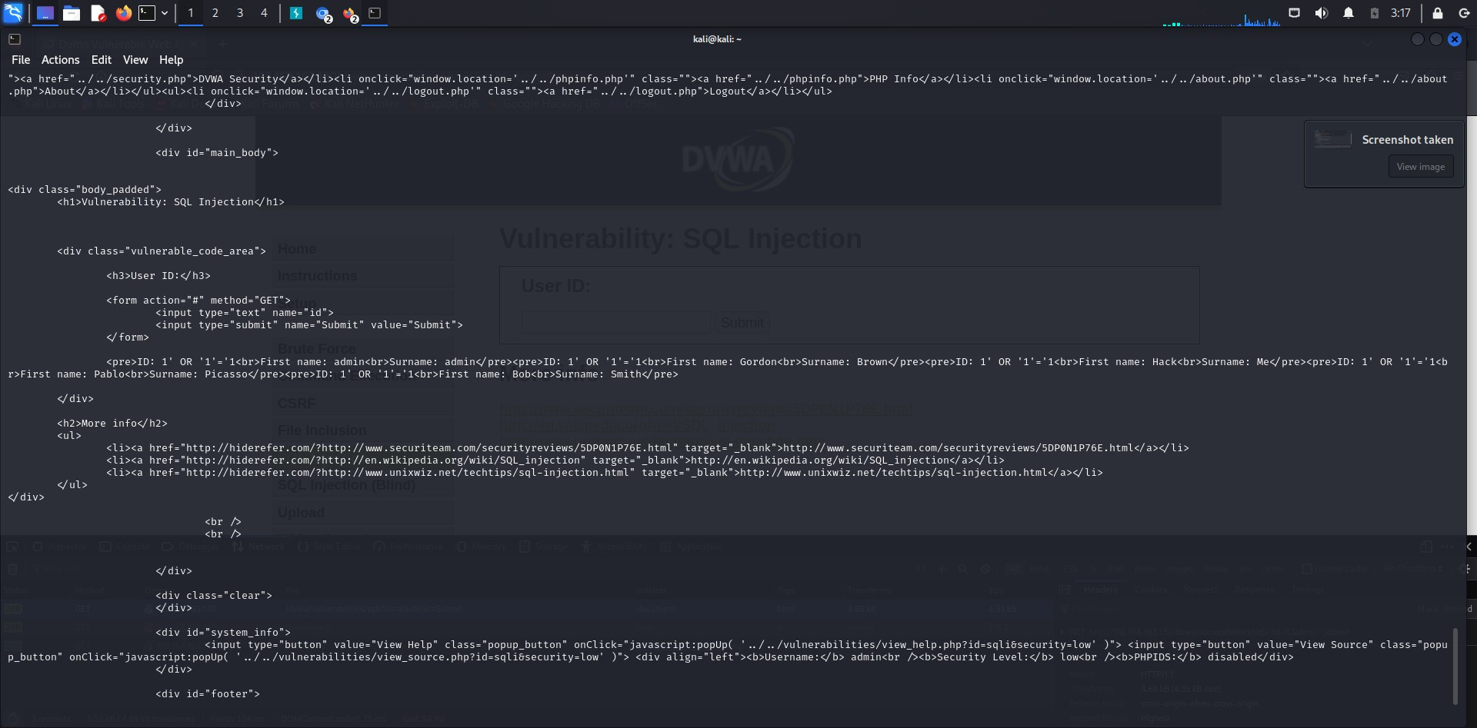 **c. Investigate POST Request Tampering:**

* Capture POST requests generated by DVWA, typically through form submissions or AJAX requests.
* Identify form fields or request parameters that are sent via POST to the application server.
* Modify these parameters to inject SQL payloads, similar to GET request tampering.
* Observe the application's response to understand the impact of parameter tampering on POST requests. **d. Test**

**Different Injection Techniques:**

* Experiment with various SQL injection techniques, including UNION-based, error-based, or time-based injections.
* Modify the injected payloads based on the observed responses to refine the tampering technique.
* Pay attention to the behavior of the application when manipulated parameters lead to successful SQL injection.

Discuss the potential impacts of parameter tampering attacks on the security and functionality of the DVWA application.

Highlight the risks associated with successful SQL injection through parameter tampering, such as data leakage or unauthorized database access.

